Ex.no:7b | DATA VISUALIZATION USING TABLEAU DIABETES PREDICTION DATASET

Aim
To connect, analyze, visualize, and create interactive dashboards using Tableau for effective data analytics using the Chess Dataset.

Algorithm: Chess Data Visualization using Tableau
Step 1: Data Loading
Connect the Chess Games Dataset to Tableau.
Import the games.csv file.
Verify the imported fields:
id, rated, created_at, last_move_at, turns, victory_status, winner, increment_code, white_id, white_rating, black_id, black_rating, moves, opening_eco, opening_name, and opening_ply.
Verify that numerical fields such as turns, white_rating, black_rating, and opening_ply are recognized as numerical measures.
Verify that fields such as rated, victory_status, winner, opening_eco, and opening_name are recognized as categorical dimensions.
Convert created_at and last_move_at into appropriate Date/Date-Time fields.

Step 2: Player Rating Bar Chart
Create a worksheet for player-rating analysis.
Place winner on Columns.
Place white_rating and black_rating on Rows.
Aggregate the rating fields using Average.
Select the Bar Chart visualization.
Enable data labels to display the average ratings.
Use the chart to compare average White and Black player ratings across different game outcomes.
Step 3: Opening-wise Chess Games Visualization
Create a worksheet using opening_name and id.
Count the number of games using id.

Sort the opening categories in descending order according to the number of games.
Select the Bar Chart visualization.
Display the opening names and corresponding game counts as labels.
Use the visualization to identify the most frequently played chess openings.
Step 4: Chess Games Trend
Create a Line Chart using created_at and id.
Place created_at on Columns.
Place id on Rows.
Aggregate id using Count.
Set created_at to Month or Year and Month.
Enable labels where appropriate.
Use the chart to observe the variation in the number of chess games over time.
Step 5: Winner Percentage
Create a calculated field named Winner Percentage.
Calculate the percentage of games for each winner category.
Use the formula:
Winner Percentage = COUNT([id]) / TOTAL(COUNT([id])) × 100
Display winner and Winner Percentage in a worksheet.
Visualize the winner percentage using a Bar Chart.
Enable labels to display the percentage values.
Use the chart to compare the percentage of games won by White, Black, and Draw.
Step 6: Rated Game Filter
Add rated to the Filters shelf.
Select a rated-game category such as True or False.
Observe the updated visualizations based on the selected rated status.
Use the filter to compare game outcomes, player ratings, and openings between rated and unrated games.
Step 7: Minimum Player Rating Parameter
Create a parameter named Minimum Player Rating.
Set the required minimum rating value.

Create a calculated field to display only games where the player ratings meet or exceed the selected value.
Apply the calculated field as a filter.
Display the parameter control on the worksheet.
For example, when Minimum Player Rating = 1500, display games where the relevant player rating is 1500 or above.
Step 8: Dashboard Creation
Create a new Tableau Dashboard.
Add the following visualizations:
Player Rating by Winner
Games by Opening
Chess Games Trend
Winner Percentage
Add the Rated filter.
Add the Minimum Player Rating parameter.
Arrange the worksheets clearly.
Format the dashboard with suitable titles, labels, and legends.

Step 9: Story Creation
Create a Tableau Story using the completed dashboard.
Add story points for:
Overall Chess Game Analysis
Winner-wise Analysis
Opening-wise Analysis
Player Rating Analysis
Game Trend Analysis
Final Chess Game Analysis
Present the visual insights using the story.
Step 10: Analysis
Analyze the charts to identify the game outcome with the highest and lowest number of games.
Compare the average White and Black player ratings across different winner categories.

Identify the most frequently played chess openings.
Observe the variation in the number of chess games over time.
Compare the percentage of games won by White, Black, and Draw.
Observe how the Rated filter dynamically changes the visualizations.
Observe how the Minimum Player Rating parameter changes the displayed games.
Use the dashboard and story to summarize the overall chess game patterns, player ratings, openings, and game outcomes.

OUTPUT:

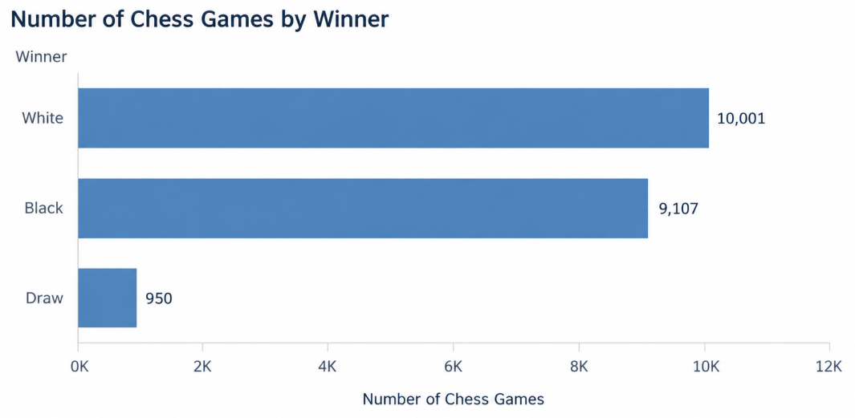

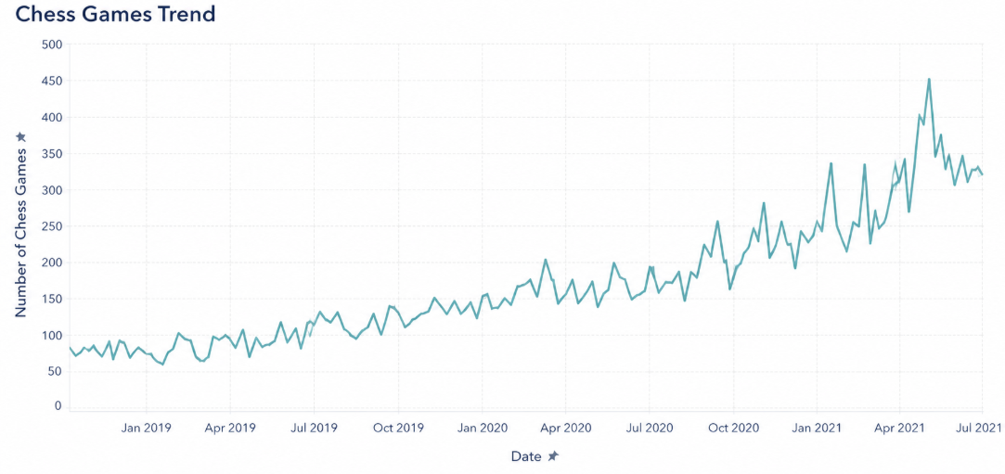

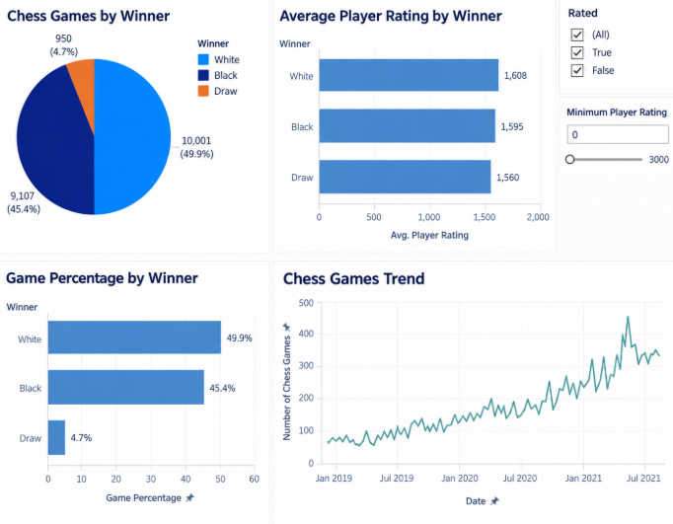

Result:

